ABOUT

Sustainable public infrastructure and service provision are heavily dependent on high-quality data for decision-making. These critical data are often unavailable in emerging economies, for lack of local expertise and resources to regularly collect, maintain, and analyze them.

The recent surge in low cost data collection, management, and analytics technologies, as well as new forms of private sector partnerships, are creating new opportunities to help governments establish low-cost, high-value data systems for green growth.

The purpose of the Sustainable Development Lab Community of Practice is to:

* Leverage data partnerships and new data methods to create globally-scalable solutions to sustainable development challenges; and
* Build human capital of both government counterparts and Bank staff in new data methods through partner coordination, training, resource provision, and community building.

LEARN MORE Button: < <https://worldbankgroup-my.sharepoint.com/:b:/g/personal/hkrambeck_worldbank_org/ETL6hYSRUU9JgbMazyGIuEgBg7sqPpnLq1DcUdFGAvQAZg?e=dcdbfs>>

JOIN US Button: [datalab@worldbank.org](mailto:datalab@worldbank.org)

FEATURED EVENTS

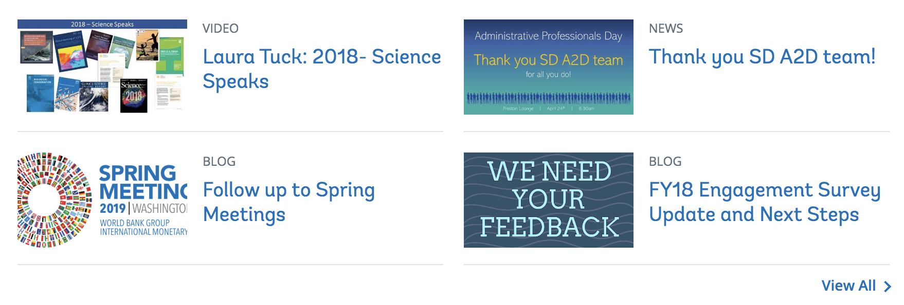

<VIEW ALL = Data Lab Tag>

* <insert .png> 09/25 FIELD TRIP Tour the US Digital Service

<https://worldbankgroup-my.sharepoint.com/:b:/g/personal/hkrambeck_worldbank_org/ES0IuxOdwnxNpcvNwTwIAn4BgcfC72eur1Xki_TTmSq1hg?e=7qFksk>

* <insert .png > 09/16 SD TECH TALKS SD Data Lab Launch

<https://worldbankgroup.sharepoint.com/:v:/t/AVSupport-WBGroup/ESQEB_o2No9Lt7TNeGfrCWUBJTEve96I_Bgs9WF8dgua4w?e=MMkp7N>

* <insert .png > 09/10 WHAT’S THE FUTURE BOOK CLUB Book Club Launch

<https://worldbankgroup-my.sharepoint.com/:b:/g/personal/hkrambeck_worldbank_org/EeSitUV3EdtNk_OZ5-Eg7u4BuyI77cIPkmv8fZ2MlHaqxw?e=OesYnd>

* <insert .png > 08/26 PARTNERSHIPS Need a Data Scientist? CalPoly Partnership Call for Proposals

<https://worldbankgroup-my.sharepoint.com/:b:/g/personal/hkrambeck_worldbank_org/ESfVgI76X1VFt0_yGbHgU0kB03sLuPKmSgagAWGmiU9IkA?e=i9NYWV>

WHAT’S THE FUTURE BOOK CLUB

Click the following links to sign up for one of the current readings or peruse past selections.

*Insert .png along right-hand column, with other text taking up 2/3 of page on left*: <https://worldbankgroup-my.sharepoint.com/:i:/g/personal/hkrambeck_worldbank_org/EVZEH6lnJNBIpv7w8KlsC7YBvVRjJjEWN4iCxB8ef5jogA?e=1RoBe9>

Sign Up for Current Selections <Button> <https://worldbankgroup-my.sharepoint.com/:b:/g/personal/hkrambeck_worldbank_org/EeSitUV3EdtNk_OZ5-Eg7u4BuyI77cIPkmv8fZ2MlHaqxw?e=OesYnd>

FY20 Q2 Selections <https://worldbankgroup-my.sharepoint.com/:b:/g/personal/hkrambeck_worldbank_org/ETiy3HtHgmBBnKSgQJevyUUBvIjbZ7OaTxzKoLjdzpLvAw?e=34Co6I>>

Download Book Club Leader Guide <https://worldbankgroup-my.sharepoint.com/:b:/g/personal/hkrambeck_worldbank_org/ESX_LnONV4NNiwOcyAJnamUBYrnbqf8UlouOe0upYtqg5Q?e=1vhD2G>

LAB COMMUNITY MEETINGS

Upcoming meetings and minutes from previous meetings are available here.

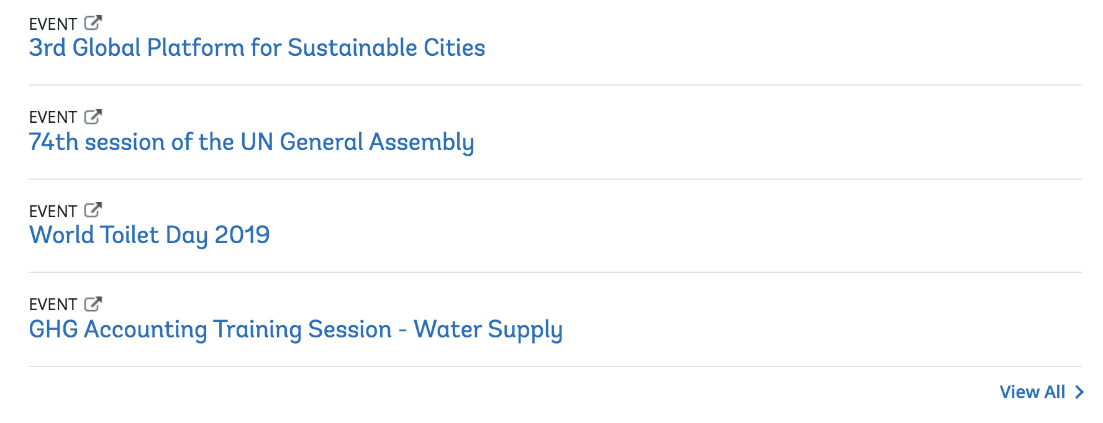

*content forthcoming*

LAB LEADS & PARTNERS

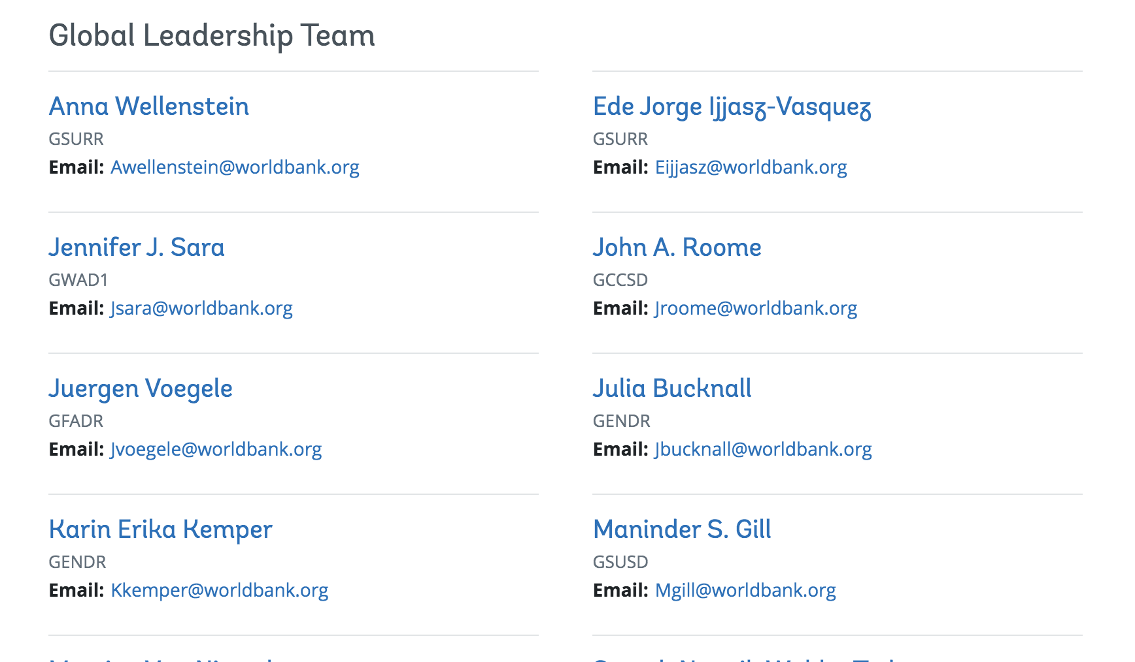

Can we add photos, using the API? Here is the link to current Leads:

<https://worldbankgroup-my.sharepoint.com/:x:/g/personal/hkrambeck_worldbank_org/EfJxTq_XE35BhkQZcSQrf_QBOp9qELVK-G8omBAggqPFFA?e=CJYj9l>

Slides: https://worldbankgroup-my.sharepoint.com/:p:/g/personal/hkrambeck_worldbank_org/EcQuEgtfu_hLjzMpkE065YEBD3hm2B-jmezdBY0HWkfZIg?e=WcBXHZ

Book Club: https://worldbankgroup-my.sharepoint.com/:b:/g/personal/hkrambeck_worldbank_org/EU6fm7DW0ElLiDVGijAhNxQB-QzJ9Z9SQPfwVNTDp-Ds6A?e=HfSEgz

Book Fair: https://worldbankgroup-my.sharepoint.com/:b:/g/personal/hkrambeck_worldbank_org/Ed4cUNyTJRVBvCzjHYm_uzMBP8uGMU_ruPCTPtV8fEQxRA?e=Bx1FGC

AWS

https://worldbankgroup-my.sharepoint.com/:w:/g/personal/hkrambeck_worldbank_org/EXCt90eBPutCrcBHplpQW08BZfn553xDLYdnhLIiCWzlZg?e=mOEgDE

SDDL Guide: https://worldbankgroup-my.sharepoint.com/:b:/g/personal/hkrambeck_worldbank_org/EUa4aJSlj_xMrjBlptOEtHUBVAw929o0dcwgicG9McfXfA?e=QIs0Ch